Survey
  - IEA SHC Task 49 - Solar Process Heat for Production and Advanced Applications

GENERAL INFORMATION
Survey questions answered by (company):
Author:
Email:
Phone:

GENERAL SYSTEM INFORMATION
Country the solar thermal system is installed:
Address:
Industry sector the solar thermal system is installed: <Please select an item>
NACE code:
Solar Thermal Energy used for:
Solar thermal system owner / operator:
Solar thermal engineering company:
Process integration engineering company:
Year / Date of operation start:
Homepage (or other source for project related information):

SOLAR THERMAL SYSTEM CHARACTERISTICS
- TECHNICAL PARAMETERS (please note the drop down lists in the table)
SOLAR HEAT SOURCE | DATA | REMARKS
Kind of solar thermal collectors installed | <Please select an item>
Installed collector area [m²] |  | <Please select an item>
Solar collector loop heat transfer fluid | <Please select an item>
Solar energy storage | <Please select an item>
Storage volume [m³]

CONVENTIONAL HEAT SOURCE | DATA | REMARKS
Kind of conventional heat source | <Please select an item>
Kind of fuel used | <Please select an item>

SOLAR HEAT INTEGRATION | DATA | REMARKS
Point of Solar Heat Integration  (please refer to Figure 1 below) | <Please select an item>
Short description of solar heat integration
How and where is solar heat integrated?
At which temperature (range) is the solar heat delivered [°C] (min/max)?

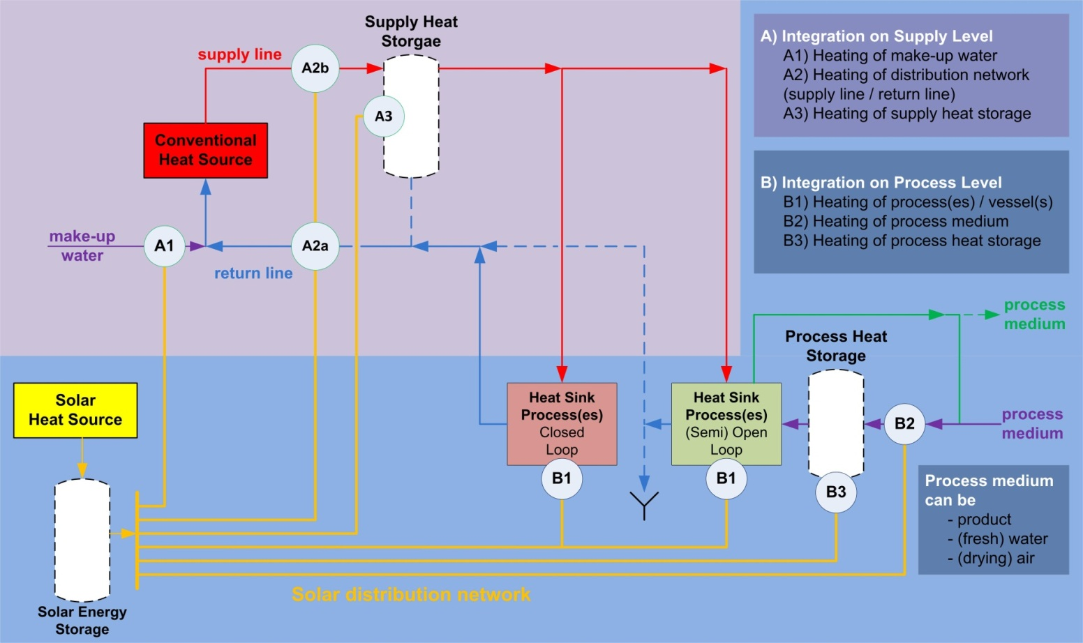
Figure 1: Possible integration points for solar process heat applications

- ECONOMIC PARAMETERS
Total investment costs excl. VAT [€]
solar thermal system (+ storage) + process integration
If possible, please specify (in € or %)
Solar loop
Solar energy storage
Process integration
Other
Subsidies [€] or [%]
Please also specify kind of subsidy (e.g. subsidies on investment costs, tax rebates, feed-in tariffs…) received:
Cost for fuel replaced [€/MWh_{fuel}]
Cost for conventional fuel replaced by solar thermal system
Calculated solar thermal system life time [a]
Annual (useful) solar heat delivery [MWh/a]
Please specify reference year(s):
Share of solar heat delivery compared to the total heat delivery at point of solar integration (solar fraction) [%]
Please specify reference year(s):

- “LESSONS LEARNED”
Initiative
Who was responsible for the initial start-up of the project with solar integration and why?
Solar thermal integration methodology
How (based on which parameters / methodology) was the point of solar thermal heat integration determined?
Designing / Tendering / Procurement
What are the most crucial interfaces? What are your experiences / lessons learned?
Construction / Commissioning
What have been the main challenges? What is your experience (positive and negative)?
Operation / Solar thermal system performance
Is there any kind of problems during operation? Does the performance meet your expectations?
Recommendations
Due to your experience, which recommendations would you give for future projects?

- ATTACHMENTS

The following attachments to this survey are kindly requested:

- Hydraulic scheme(s) of the solar thermal system integration
☐ Attached
- Data sheet(s) of the solar thermal collector(s) in operation
☐ Attached
- Pictures with permission for publication of the solar thermal system / energy storage / process integration measures
☐ Attached

Thank you for your valuable contribution to the IEA Task 49 “Solar Process Heat for Production and Advanced Applications”
http://www.iea-shc.org/task49/

Please send this completed questionnaire + attachments per e-mail to
w.glatzl@aee.at
http://www.aee-intec.at/

